Hardware Firewall

🛡️ What is a Hardware Firewall?
# Source: Chatgpt (GPT‑5 Mini) at [12/18/2025]
A Hardware Firewall is a dedicated physical device that protects a network by monitoring and filtering incoming and outgoing traffic according to a set of security rules. It acts as a protective gateway between your internal network and external threats (like the internet).
✅ Think of it as a specialized security box that sits between your network and the outside world, inspecting all data that passes through.

🔧 Key Functions
# Source: Chatgpt (GPT‑5 Mini) at [12/18/2025]
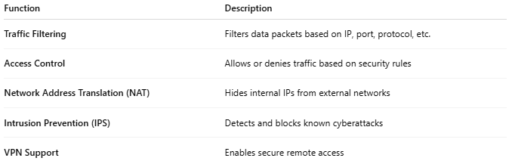
Function | Description
Traffic Filtering | Filters data packets based on IP, port, protocol, etc.
Access Control | Allows or denies traffic based on security rules
Network Address Translation (NAT) | Hides internal IPs from external networks
Intrusion Prevention (IPS) | Detects and blocks known cyberattacks
VPN Support | Enables secure remote access

📶 Where It’s Placed in a Network
# Source: Chatgpt (GPT‑5 Mini) at [12/18/2025]
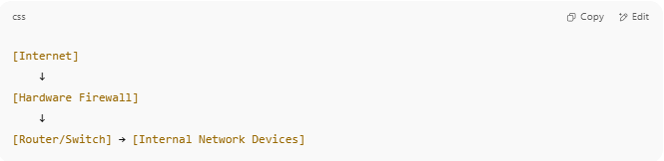
[Internet]
↓
[Hardware Firewall]
↓
[Router/Switch] → [Internal Network Devices]

- All traffic enters and exits through the firewall, which filters and logs it.

🧠 Hardware Firewall vs Software Firewall
# Source: Chatgpt (GPT‑5 Mini) at [12/18/2025]
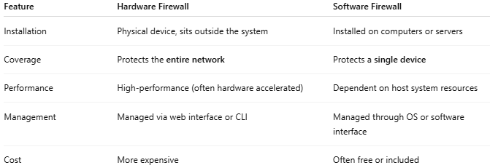
Feature | Hardware Firewall | Software Firewall
Installation | Physical device, sits outside the system | Installed on computers or servers
Coverage | Protects the entire network | Protects a single device
Performance | High-performance (often hardware accelerated) | Dependent on host system resources
Management | Managed via web interface or CLI | Managed through OS or software interface
Cost | More expensive | Often free or included

✅ Advantages
# Source: Chatgpt (GPT‑5 Mini) at [12/18/2025]
- ✅ Protects all devices on the network
- ✅ More secure than software-only firewalls
- ✅ Does not rely on a PC’s resources
- ✅ Often includes advanced features (VPN, IPS, VLANs)
- ✅ Suitable for business and enterprise use

❌ Disadvantages
# Source: Chatgpt (GPT‑5 Mini) at [12/18/2025]
- ❌ Higher upfront cost
- ❌ Requires technical knowledge to configure
- ❌ Less flexible than cloud-based or software firewalls for some use cases

🏷️ Popular Hardware Firewall Devices
# Source: Chatgpt (GPT‑5 Mini) at [12/18/2025]
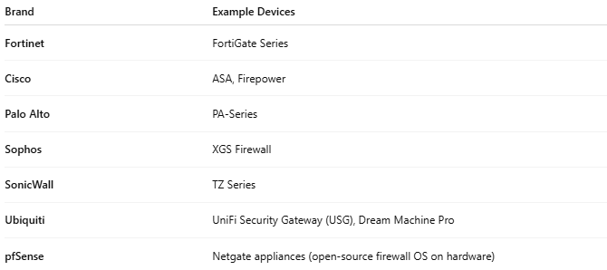
Brand | Example Devices
Fortinet | FortiGate Series
Cisco | ASA, Firepower
Palo Alto | PA-Series
Sophos | XGS Firewall
SonicWall | TZ Series
Ubiquiti | UniFi Security Gateway (USG), Dream Machine Pro
pfSense | Netgate appliances (open-source firewall OS on hardware)

📌 Summary
# Source: Chatgpt (GPT‑5 Mini) at [12/18/2025]
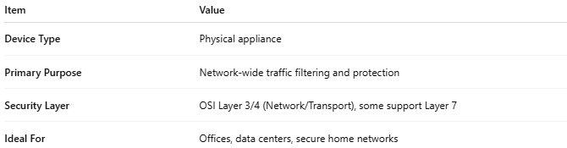
Item | Value
Device Type | Physical appliance
Primary Purpose | Network-wide traffic filtering and protection
Security Layer | OSI Layer 3/4 (Network/Transport), some support Layer 7
Ideal For | Offices, data centers, secure home networks

